Monday
The Annunciation
The angel Gabriel appeared to Mary of Nazareth and announced that she would give birth to a son and he was to be named Jesus. This is called the Annunciation.

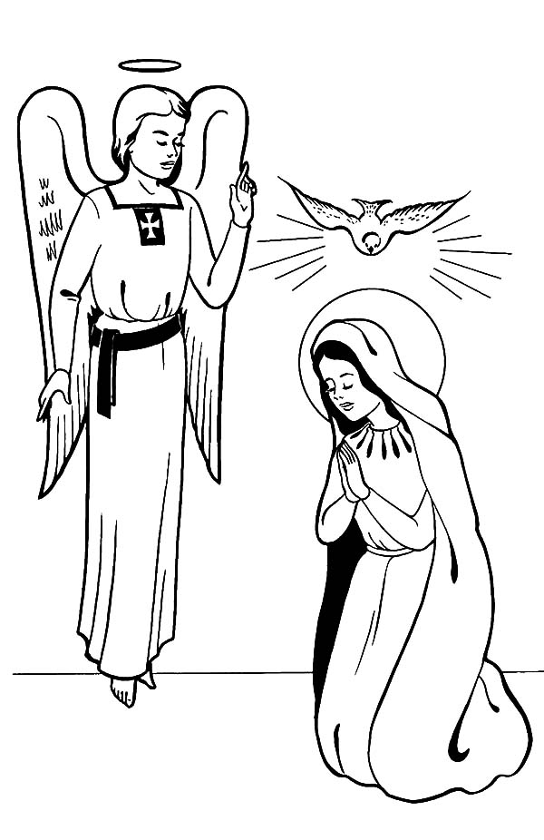

Tuesday
The Annunciation
Mary said yes!

Draw what happened..

Wednesday
My Family Christmas
At Christmas time my family..

My favourite part about Christmas is..

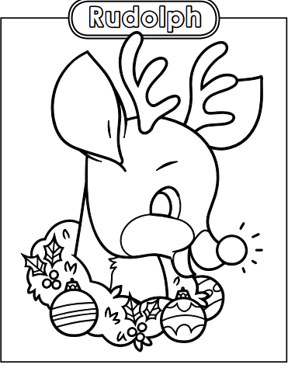
Thursday

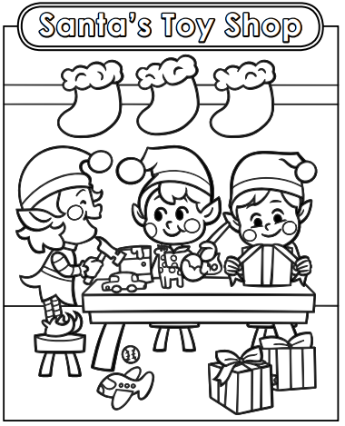
Friday

